The Prelude

**\*Chiming of the Hour**

**The Call to Worship**

Come to Christ, that living stone, rejected by the world, but in God’s sight chosen and precious.

**We have responded to Christ’s call, and seek to be built into a spiritual house, a living reminder of God’s presence on earth.**

Once we were no people, but now we are God’s people, called out of the darkness into God’s marvelous light. Therefore, we sing with the church in all ages:

**Blessed be your name, O God, our Redeemer. By your mercy we have been born anew to a living hope through the resurrection of Jesus Christ from the dead.**

**\*Hymn** “I Am Thine, O Lord” UMH 419

**The Opening Prayer**

**Almighty and everlasting God, in whom we live and move and have our being, you created us for yourself, so that our hearts are restless until they find rest in you. Grant to us such piety of heart and strength of purpose that no selfish passion may hinder us from knowing your will and no weakness from doing it. In your light may we see life clearly and, in your service, find perfect freedom; through Jesus Christ our Lord. Amen.**

**Welcome and Announcements**

**Canned Food Collection**

**Time of Sharing and Prayer**

Celebrations of God’s Grace and Prayer Concerns

The Pastoral Prayer/The Lord’s Prayer (UMH 895)

**\*Hymn** “O Jesus, I Have Promised” UMH 396

**The New Testament Reading** – Galatians 6:7-16 p. 1757

**The Gospel Reading** – Luke 10:1-11, 16-20 p. 1561

This is the Word of God for the people of God.

**Thanks be to you, Lord Jesus Christ.**

**Prayer for Illumination**

**The Message** “*It Takes A Team*”

**The Receiving of God’s Tithes and Our Offerings**

**The Response:** “In the Lord, I’ll Be Ever Thankful” (2x)

*In the Lord, I’ll be ever thankful, in the Lord I will rejoice!*

*Look to God, do not be afraid. Lift up your voices, the Lord is near,*

*Lift up your voices: The Lord is near.*

**\*The Doxology** (UMH 95)

**\*The Prayer of Dedication:** O God, most merciful and gracious, of whose bounty we have all received, accept this offering of your people. Remember in your love those who have brought it and those for whom it is given, and so follow it with your blessing that it may promote peace and goodwill among all peoples and advance the Kingdom of our Lord and Savior Jesus Christ. **Amen.**

**Service of Holy Communion (UMH 12)**

**Invitation, Confession and Pardon**

The Great Thanksgiving

**Giving the Bread and the Cup**

**\*Hymn** “For the Bread Which You Have Broken” UMH 614

**\*The Charge and Blessing:**

May the presence of God the Creator give you strength,

May the presence of God the Redeemer give you peace,

May the presence of God the Sustainer give you comfort,

May the presence of God the Sanctifier give you love. **Amen.**

**Postlude** “Bless the Lord” (2X)

Bless the Lord, my soul, and bless God’s Holy name.

Bless the Lord, my soul, who leads me into life.

*\*Please stand as you are able.*

**Assisting with Wors**h**ip Today July 14, 2019_____**

**Scripture Readers** _______________ Volunteer Needed

**Greeters** _______________ Volunteer Needed

**Volunteers Needed:** The sign-up sheet for July and August is available now.

**Welcome Cards –** We welcome all our guests. There are welcome cards located in the pews. Please take a moment to fill one out and place it into the offering plate during the collection.

**About Fletcher’s Chapel Church**

**Our Vision** is to be a beacon in the name of Jesus Christ to the world, to make disciples of Jesus Christ and to send them forth to proclaim God’s Word and serve God’s will everywhere and always.

**Our Mission:** “19Go therefore and make disciples of all nations, baptizing them in the name of the Father and of the Son and of the Holy Spirit, 20and teaching them to obey everything that I have commanded you. And remember, I am with you always, to the end of the age.” -- Matthew 28:19-20

**Email:** [barryburkholder@vaumc.org](mailto:barryburkholder@vaumc.org) or [fletcherschapel@verizon.net](mailto:fletcherschapel@verizon.net)

**“Like” us on Facebook:** Search for “Fletcher’s Chapel UMC-King George, VA” and when you find our page, click “Like” so you can keep up with the latest news and events at Fletcher’s Chapel.

**MINISTERS: All Members**

**PRESIDING BISHOP: Sharma D. Lewis**

**DISTRICT SUPERINTENDENT: Theodore Smith**

**PASTOR: Barry Burkholder**

**LAY LEADER: Marie Williams**

**MUSICIAN Elizabeth Pruett**

**Fletcher’s Chapel United Methodist Church**

**8330 Fletcher’s Chapel Road, King George, VA 22485**

**www.fletcherschapel-kinggeorge-va.org**

**Church: (540) 775-7247 Parsonage: TBD**

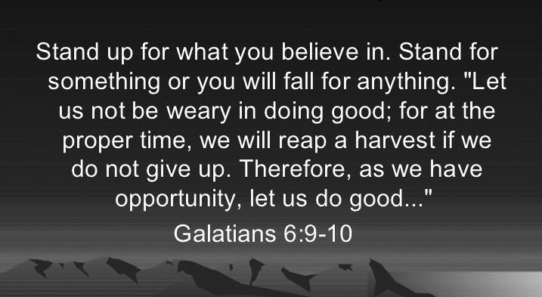

**The Fourth Sunday after Pentecost, July 7, 2019 8:30 a.m. & 11:00 a.m.**

**July 7, 2019 – July 14, 2019**

**Sunday, July 7 Communion Sunday/Canned Food Collection**

**8:30am** Worship

**9:45am** Sunday School Opening

**10:00am** Sunday School

**11:00am** Worship

**Weds, July 10 10:00am** Morning Prayer Group

**Sunday, July 14 Loose Change Collection/Coffee Fellowship**

**8:30am** Worship

**9:30am** Coffee Fellowship

(Hosted by Kenny & Stephenie Newton)

**10:00am** Sunday School

**11:00am** Worship

**3:00pm** Welcome Reception for Rev. Burkholder and his

Wife, Gerry in the Fellowship Hall

**Upcoming:**

**Weds, July 17 9:30am** Heritage Hall Nursing Home Ministry

**Weds, July 17 6:00pm** Ice Cream Social at Fairview Beach

**Monday, July 22 6:00pm Vacation Bible School Begins**

**Weds, July 24 10:00am** Morning Prayer Group

**Thursday, July 25 6:00pm Last day of Vacation Bible School**

**Birthdays This Week**

**7/12:** Diane Sill

**† † †**

**The Welcome Reception** for Reverend Barry Burkholder and his wife, Gerry, will be held on Sunday, July 14 at 3:00 p.m. in the Fellowship Hall.

**Canned Food Offering Today!** The Canned Food Offering is collected on the first Sunday of each month. This food will be sent to the King George Social Services Food Bank. King George County residents who need assistance may receive a two- or three-day emergency supply of food once a month with proof of residency.

**Prayer Concerns:**

**Prayers for our Community and the World:** The congregation and guests of Fletcher’s Chapel and our community; the residents and staff of the Thurman Brisben Center; Our Bishop and her cabinet.

**Prayers for Our Church Family:** Dee Campbell, Patricia Clatterbuck, Delores Coates, John Earl Coates, Audrey Davenport, Robin DeWaters, Ruby Hawkins, Louise Henderson, Grace Radolinski, Bob Hunter, Evelyn Jackson, Lolita James, Turner Minx, David Pitts, Clifton Seay, Shirley Seay

**Prayers for our Families and Friends:** Gavin Balderson, Donnie Bullock, Mitchell Burroughs, Barbara Canady, JoAnn Carpenter, Drew Cleveland, Judy DeWaters, Anne Emery, Judy Fisher, David Frazier, Frazier Family, Gage Ford & Family, Bobby Garner, John Gayle, Anna Graninger, Chip Hall, Faye Holt, Clair Hunkins, David Kane, Bishop Sharma Lewis, Nancy Chappell Madison, Jim McCurtain, Jennifer Paling, Joey Rowe, Brian Scott, Jean Stone, Billy Sullivan, Ryland Tedeton, Mike Warnke, Fred Weaver, Robin Wolanin, Cynne White Wolf

***Prayer Request Cards*** *are available in the pew rack*